OCEANA COUNTY

**JUNIOR MARKET**

**DUCK RECORD BOOK - 2023**

**(for ages 5-7)**

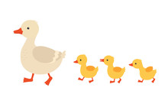

As a member of the Junior Market Animal Project, you are required to submit your records as part of an educational project notebook in order to show your animal at the Oceana County Fair. **This notebook must be shown to the Poultry Superintendent or designated Small Market Weighmaster at the time of weigh-in and then entered by you in the Educational Notebook Division at the Oceana County Fair on Entry Day.**

**IF YOU ARE A LITTLE BUDDY PLEASE CHECK HERE: _____**

My big buddy is: _________________________________________

**AGE: __________**

The age you enter depends on how old you were on January 1, 2023.

**NUMBER OF YEARS IN PROJECT: __________**

Use this sheet as the first page of your project record book. Fill it out completely.

**Please print or type neatly**.

# NAME __________________________________________________________________________

**4-H CLUB ______________________________________________________________________**

**LEADER _______________________________________________________________________**

##### DATE RECORDS STARTED ___________________ DATE ENDED _______________________

**JUDGE’S SCORE/COMMENT SHEET**

**(PLEASE DO NOT REMOVE, PLACE THIS SHEET IN SHEET PROTECTOR OR GLUE TO COVER). This sheet must be keep free to the judge to write their comments.**

This sheet should help each 4-H’er understand their ribbon placing.

A. **Specific educational value or worth**

___ All questions were answered completely

___ All calculations were correct

___ Calculations were incorrect

___ Questions were not completely answered

___ Questions were not answered (missed questions)

B. **Notebook contains all project records**

___ Notebook contained all project records and were fully completed

___ Notebook contained additional project related information (research

materials etc.)

___ Project records were incomplete

___There was no additional project related information

C. **Accuracy, neatness and general appearance**

___Notebook was neat in appearance (typed/hand printed)

___ Notebook pages were clean and stain free

___Notebook pages were in order and complete

___Notebook pages were out of order and missing pages

___Notebook was difficult to read and messy

___Notebook had wrinkled and stained pages

Other Comments: _______________________________________________________________________

_________________________________________________________________________________________

_____________________________________________________________________________________**____**

2023-JR Market Ducks Page 2

## OBJECTIVES

1. Develop desirable work habits, sportsmanship, and ability to cooperate and express ideas through participation in projects, discussions, method demonstrations, judging teams, and exhibits.
2. Experience the pride and responsibility of leasing/owning & caring for poultry.
3. Learn how to feed, fit, show, breed and raise poultry.
4. Learn proper handling procedures to prevent injuries to 4-H members and their poultry projects.
5. Appreciate and use scientific information in poultry production and marketing.
6. Improve knowledge of grading, marketing and merchandising of poultry and poultry products.
7. Improve knowledge of the nutritive value of poultry meat and eggs and how they contribute toward good health.
8. Learn the importance of the poultry industry to the local, state, and national economies.
9. Acquire information on the opportunity that poultry offers as a career.

This record book is part of your Junior Market Duck project. By keeping records up-to-date you will be able to see how much progress you make as you set goals and work to accomplish them. Write or type neatly and clearly. Please keep the pages in order. Feel free to add extra pages at the end of your notebook. Pictures are a required part of your notebook. Taking pictures of your project animal throughout the project will indicate how your animal has grown and developed. Add pictures to your notebook on a separate piece of paper.

SCORING CRITERIA

The following breakdown will be used during the judging process of all market livestock notebooks.

A. Specific educational value or worth **30%**

B. Creative way of showing what has been learned **10%**

C. Notebooks contains all project records **50%**

D. Accuracy, neatness and general appearance **10%**

The Oceana County Agricultural Society encourages parent assistance with your project and project notebook.

**If a parent or adult helped you in filling out your notebook** please have them sign below that the answers are YOUR answers and that they assisted you in writing of the answers and understanding of the questions only.

_________________________________________________________

(Signature of person helping with notebook)

_________________________________________________________

(Signature member)

2023-JR Market Ducks Page 3

**ABOUT YOUR DUCKS**

***My Ducks Names*** ***are:***  (if you did not name your market ducks, what is the name of your showmanship bird)

________________________________________________________________________

***My Duck’s breeds*** ***are***: ______________________________________________

***What color are your Ducks***? _________________________________________

***My Ducks favorite thing to do is***: ___________________________________

________________________________________________________________________

## WEIGHT CHART

|  |  |  |
| --- | --- | --- |
| Date | Age | **Weight** |
|  |  |  |
|  |  |  |
|  |  |  |
|  |  |  |
|  |  |  |

**FINAL WEIGHT (FW) ___________ AGE__________ DATE___________**

***\*Final weight may need to be estimated depending on Covid-19 restrictions***

2023-JR Market Ducks PAGE 4

## EXPENSES

##### (A) Cost of ducklings $_______________________

|  |  |  |  |
| --- | --- | --- | --- |
| **DATE** | LBS. OF FEED | FEED TYPE/VARIETY | COST |
|  |  |  | **$** |
|  |  |  |  |
|  |  |  |  |
|  |  |  |  |
| **(B)** |  | **TOTAL SPENT ON FEED** | **$** |

|  |  |  |
| --- | --- | --- |
| **DATE** | OTHER EXPENSES, VET, SUPPLIES, HOUSING, ETC. | COST |
|  |  | **$** |
|  |  |  |
|  |  |  |
|  |  |  |
| **(C)** | **TOTAL SPENT ON OTHER EXPENSES** | **$** |

##### GRAND TOTAL OF ALL EXPENSES (TE): $ _______________________

**(total of A, B and C)**

**_______________ ÷ _________________ = __________________________________________**

Total Expenses **(TE)** Final Weight **(FW)** Break Even Price **(BE)**

(or total cost per pound to raise your animal)

***\*\* have your parent, leader or an older teen in your club help you figure out your breakeven price. The breakeven price is the price that you need to get at the***

***Junior Market animal auction in order to not lose money on your market project. \*\****

2023-JR Market Ducks PAGE 5

**ANIMAL CARE AND MANAGEMENT- JOURNAL OF CARE**

Your project requires regular care and management.

Include the following:

* Feeding and watering practices
* Health practices and medicines (vaccinations, etc.)
* General Management (building a cage, cleaning living area, feed pans, ponds, etc.)

|  |
| --- |
| **Daily- Things done once or twice a day** |
|  |
| **Weekly- Things done once or twice a week** |
|  |
| **Monthly- Things done once a month** |
|  |
| **Yearly- Things done one time or occasionally throughout the year** |
|  |

2023- JR Market Ducks PAGE 6

**MARKETING**

One of the most important parts of any market animal project is marketing. This may include writing letters and talking to prospective buyers. Color in the face, a smiling face is a good action, a frowning face is a bad action. (see the example)

**Good Marketing Practice Poor Marketing Practice**





























Send a reminder to attend the auction

Make sure you go with an adult to speak with potential buyers

Know what kind of feed you used if asked

Only go to grocery stores or the bank

Don’t ask your former buyers as you don’t want to bother them

Only thank those who agree to be listed as a potential buyer

**WHAT DOES YOUR DUCK NEED?**

(have an adult help you read the following & then **circle those items that your ducks** need below)

All living creatures need certain things to survive, like *food*, *water* and shelter. *Farmers* take care of their animals to make sure they are healthy and comfortable. If any ducks are sick the farmer will treat them with the help of the *veterinarian.* Ducks enjoy *pellets & eat bugs* but should never be fed *dried beans*. Ducks do like to swim in a *pond* if one is available.

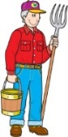

FARMER CAKE ***MOLDY*** PELLETS

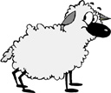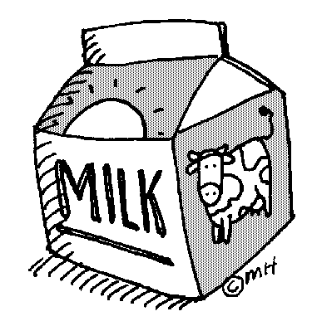

BARN

FARMER

BIKE

JUICE

WATER

CLOTHES

MILK

CORN

VETERINARIAN

TV

CAKE

WATER CHOLOLATE CHIPS POND VETERINARIAN

2023-JR Market Ducks Page 7

**IDENTIFY THE PARTS OF A DUCK**

(fill in the boxes in the above picture with the letter corresponding to the correct part)

A. EYE K. SHANK

B. NECK L. ABDOMINAL AREA

C. SECONDARY WING FEATHERS M. FOOT

D. COVERTS N. CROWN

E. WEB O. EAR

F. CROP AREA P. BACK

G. BEAN Q. CHEEK

H. TAIL R. BILL

I. PRIMARY WING FEATHERS S. BREAST AREA

J. TOE

J. TOE

2023-JR Market Ducks Page 8

**CONNECT THE DOTS AND COLOR THE DUCK**

2023-JR Market Ducks Page 9 **SHOWMANSHIP**

Circle the Correct Answer to Each Question

1. While showing your duck make sure that you:

A) Avoid eye contact with the judge and keep an eye on your duck at all times.

B) Stare at the judge with a serious expression the entire time

C) Be alert, smile and look at the judge from time to time

2. When showing your duck you need to use extreme care with:

A) The bill of the duck

B) The ducks head

C) The legs of the waterfowl

3. When posing the duck on the table for the judge:

A) You should hold the duck in place

B) The duck should not sit down, walk or fly away

C) The duck should sit down

4. The first four steps of examining the duck are:

A) Take in overall appearance; examine head, eyes, and bill

B) Neck, back, tail area, vent opening

C) Examine the shanks, toe, webs, and foot

5. When holding the duck you should:

A) Hold the duck right in front of you, do not touch its crop to your belly

B) Hold the duck away from your body as not to touch it

C) Hold it sideways with its crop touching your belly

6. When the judge gives the command to “remove your duck” you should:

A) Remove the duck backside first

B) Remove the duck head first and take a step backward

C) Let the duck walk out of the cage

7. To pose the duck you should use:

A) A training stick

B) Your hand only

C) Voice command

2023-JR Market Ducks Page 10

**IDENTIFY GOOD AND BAD CHARACTER ACTIONS**

Color in the face, a smiling face = a good action; a frowning face = a bad action.

**RAISING and SHOWING an RAISING and SHOWING an**

**ANIMAL *with* CHARACTER ANIMAL *without* CHARACTER**









































Feed Animals on Time

Complain about the judge

Clean cages whenever you feel like it

Thank the judge for their time

Congratulate whoever places first

Help others if they need it

Leave animals outside without shelter

Share your equipment if asked

Have your leader complete your record book

Insult competitors

**4-H INFORMATION**

How did you show good character this year? Did you help someone, or maybe you treated your animals extra special?

__________________________________________________________________________________________

__________________________________________________________________________________________

__________________________________________________________________________________________

2023-JR Market Ducks Page11

**PROJECT INFORMATION**

**What Does Not Belong?**

In each statement one word does not belong, ***X (cross)*** out that word.

1. Poultry have: **feathers, eyes, beaks, fur**

2. Poultry eat: **insects, plastic, pellets, grasses**

3. The people who help me take care of and learn about my ducks are:

**my parents, the plumber, the veterinarian, my club leader**

4. Duck breeds: **Pekin, Orpington, Rouen, Leghorn**

**Finish the Sentences**

1. My duck always needs clean, fresh __________________________________ to drink.

2. When I grow up I want to be a _________________________________________________.

3. The best, or most fun, part of my project was: __________________________________

_______________________________________________________________________________

_______________________________________________________________________________

______________________________________________________________________________

4. The hardest part of my project was: _________________________________________

_______________________________________________________________________________

_______________________________________________________________________________

_______________________________________________________________________________

2023-JR Market Ducks Page 12

**4-H KNOWLEDGE**

**The 4-H Pledge**- *Draw a line to the picture that fills in the blank* (see the example)

***I pledge…***

WORLD

HEALTH

HANDS

HEAD

HEART

CLUB

COUNTRY

COMMUNITY



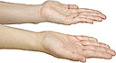

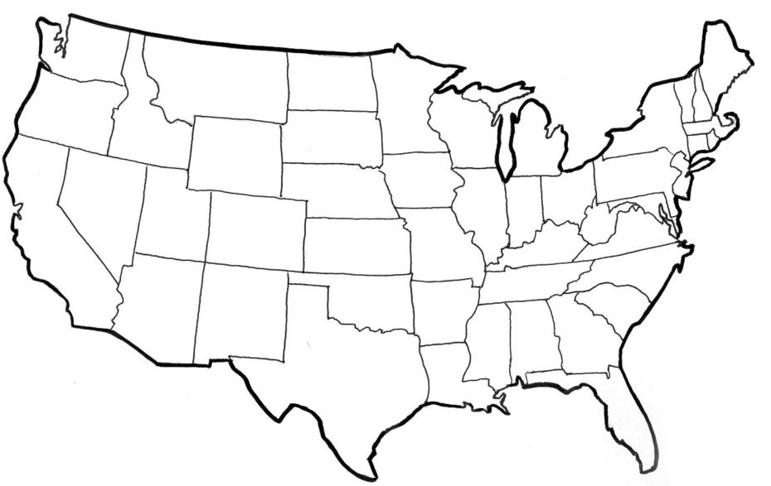



My ____________ to clearer thinking,

My ____________ to greater loyalty,

My ____________ to larger service, and

My _____________ to better living,

for my ____________________,

my _______________________,

my _______________________,

and my ____________________.

Number of club meetings held: **__________** Number I attended: **_________**

2023-JR Market Ducks PAGE 13

**MY STORY**

(Interesting things that happened to me and my animal this year, challenges, highlights of my year or ***ANYTHING*** I would like to share about my overall

experience. You can even draw a picture of you and your animals if you prefer).

***POTENTIAL BUYERS NAMES***

As part of your 4-H Small Market Livestock Project, you must personally contact at least three potential buyers before the Oceana County Fair. You are encouraged to seek two new buyers that have not been asked or submitted before. **You also must have at least three different buyers than those of your siblings in the market livestock project.** Please confirm with your buyers their accurate mailing address (example: post office box vs. a street address). The information on page 14 must be completed and taken to the Oceana County MSU Extension Office on or before the due date where it will be **copied** and used to send out letters to your potential buyers. This page will remain in your notebooks. This is a Market Livestock Committee rule. Failure to comply will result in not being able to sell your animal in the 4-H Market

Livestock Sale.

Page 14 Date: _______________

2023-JUNIOR MARKET DUCKS Staff: __

_____________

**JUNIOR MARKET/SMALL MARKET POTENTIAL BUYER’S LIST**

**DUCK PROJECT (AGES 5-7)**

Name______________________________ Club_________________________

***Please print business names and complete addresses clearly.***

* 1. Contact Name ________________________________________________­­____

Business Name ____________________________________________________

**Mailing** Address _________________________City__­­­­­­­­__­­­­­­­_____________Zip_____

Phone _______________________ After Hours Phone______________________

Mailing Preference (Please Check One): Email ____ Postal Delivery ____

Email ____________________________________________________________

Signature__________________________________________________________

2. Contact Name ________________________________________________­­____

Business Name ____________________________________________________

**Mailing** Address _________________________City__­­­­­­­­__­­­­­­­_____________Zip_____

Phone _______________________ After Hours Phone______________________

Mailing Preference (Please Check One): Email ____ Postal Delivery ____

Email ____________________________________________________________

Signature__________________________________________________________

3. Contact Name ________________________________________________­­____

Business Name ____________________________________________________

**Mailing** Address _________________________City__­­­­­­­­__­­­­­­­_____________Zip_____

Phone _______________________ After Hours Phone______________________

Mailing Preference (Please Check One): Email ____ Postal Delivery ____

Email ____________________________________________________________

Signature__________________________________________________________

(Must be stamped by the MSU Extension Office)

2023-JR Market Ducks PAGE 15

**PICTURES OF YOUR PROJECT**

(Please use this page for your project pictures. Add additional pages if you would like. The judges appreciate you labeling the pictures so they know what the picture shows.)

***NON-CLUB* POINTS- JUNIOR/SMALL MARKET PROJECT**

***(This must be filled out by participant before presenting for signatures at the MSUE office)***

|  |  |  |  |  |
| --- | --- | --- | --- | --- |
| **MEETING NAME** | **LOCATION** | **DATE** | **POINTS** | **SIGNATURE OF LEADER, SUPERINTENDENT OR MSU STAFF** |
|  |  |  |  |  |
|  |  |  |  |  |
|  |  |  |  |  |
|  |  |  |  |  |
|  |  |  |  |  |
|  |  |  |  |  |
|  |  |  |  |  |
|  |  |  |  |  |
|  |  |  |  |  |
|  |  |  |  |  |

Please note: This form must be included with your record notebook and turned into the weigh master on entry day of the Fair. **BEFORE SEEKING SIGNATURES AT MSU EXTENSION – MEETING NAME AND DATE MUST BE COMPLETED** You need to accumulate **nine (9) points** to be allowed to sell your animal. **Six (6)** of these **nine (9) points** must come from club meetings. The **three (3)** non-club points must be earned from attending various 4-H events and activities. See your leader, the MSUE office, or online at <https://www.canr.msu.edu/oceana/oceana_county_4_h/oceana_4_h_market_livestock> for a listing of approved nonclub points.

**JUNIOR/SMALL MARKET PROJECT CLUB POINTS**

***(This must be filled out by participant before presenting for signatures at the MSUE office)***

|  |  |  |  |  |
| --- | --- | --- | --- | --- |
| **MEETING NAME** | **LOCATION** | **DATE** | **POINTS** | **SIGNATURE OF LEADER, SUPERINTENDENT OR MSU STAFF** |
|  |  |  |  |  |
|  |  |  |  |  |
|  |  |  |  |  |
|  |  |  |  |  |
|  |  |  |  |  |
|  |  |  |  |  |
|  |  |  |  |  |
|  |  |  |  |  |
|  |  |  |  |  |
|  |  |  |  |  |
|  |  |  |  |  |

Please note: This form must be included with your record notebook and turned into the weigh master on entry day of the Fair. You need to accumulate **nine (9) points** to be allowed to sell your animal. **Six (6)** of these **nine (9) points** must come from club meetings. The **three (3)** non-club points must be earned from attending various 4-H events and activities